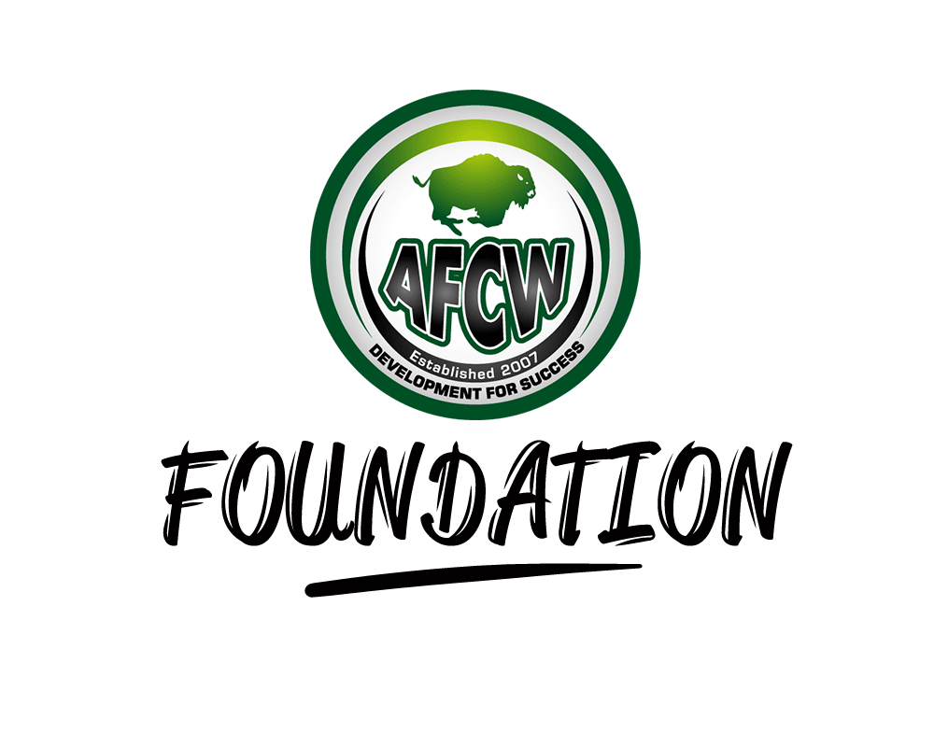

Safeguarding Children

Policy

Safeguarding is everyone’s responsibility:
Child protection is a part of safeguarding and promoting welfare. This refers to the activity which is undertaken to protect specific children who are suffering or are at risk of suffering significant harm. As adults and/or professionals or volunteers, everyone has a responsibility to safeguard children and promote their welfare.
Safeguarding and promoting the welfare of children – and in particular protecting them from significant harm - depends upon effective joint working between agencies and professionals that have different roles and expertise.
Individual children, especially some of the most vulnerable children and those at greatest risk of social exclusion, will need co-ordinated help from health, education, children’s social care, and quite possibly the voluntary sector and other agencies, including youth justice services.
For those children who are suffering, or at risk of suffering significant harm, joint working is essential, to safeguard and promote welfare of the children and where necessary to help bring to justice the perpetrators of crimes against children. All working for and with AFC Wembley Foundation should:
- be alert to potential indicators of abuse or neglect;
- be alert to the risks which individual abusers, or potential abusers, may pose to children;
- share and help to analyse information so that an assessment can be made of the child’s needs and circumstances;
- contribute to whatever actions are needed to safeguard and promote the child’s welfare;
- take part in regularly reviewing the outcomes for the child against specific plans; and
- work co-operatively with parents unless this is inconsistent with ensuring the child’s safety.

Definitions of abuse and neglect:
Abuse and neglect are forms of maltreatment of a child. Somebody may abuse or neglect a child by inflicting harm, or by failing to act to prevent harm. Children may be abused in a family or in an institutional or community setting; by those known to them or, more rarely, by a stranger. They may be abused by an adult or adults or another child or children.

Physical abuse
Physical abuse may involve hitting, shaking, throwing, poisoning, burning or scalding, drowning, suffocating, or otherwise causing physical harm to a child. Physical harm may also be caused when a parent or carer fabricates the symptoms of, or deliberately induces illness in a child.

Emotional Abuse
Emotional abuse is the persistent emotional maltreatment of a child such as to cause severe and persistent adverse effects on the child’s emotional development. It may involve conveying to children that they are worthless or unloved, inadequate, or valued only insofar as they meet the needs of another person. It may feature age or developmentally inappropriate expectations being imposed on children. These may include interactions that are beyond the child’s developmental capability, as well as overprotection and limitation of exploration and learning, or preventing the child participating in normal social interaction. It may involve seeing or hearing the ill-treatment of another. It may involve serious bullying causing children frequently to feel frightened or in danger, or the exploitation or corruption of children. Some level of emotional abuse is involved in all types of maltreatment of a child, though it may occur alone.

Sexual Abuse
Sexual abuse involves forcing or enticing a child or young person to take part in sexual activities, including prostitution, whether or not the child is aware of what is happening. The activities may involve physical contact, including penetrative (eg: rape, buggery or oral sex) or non-penetrative acts.
They may include non-contact activities, such as involving children in looking at, or in the production of, pornographic material or watching sexual activities, or encouraging children to behave in sexually inappropriate ways.

Neglect
Neglect is the persistent failure to meet a child’s basic physical and/or psychological needs, likely to result in the serious impairment of the child’s health or development. Neglect may occur during pregnancy as a result of maternal substance abuse. Once a child is born, neglect may involve a parent or carer failing to provide adequate food and clothing, shelter including exclusion from home or abandonment, failing to protect a child from physical and emotional harm or danger, failure to ensure adequate supervision including the use of inadequate care-takers, or the failure to ensure access to appropriate medical care or treatment. It may also include neglect of, or unresponsiveness to, a child’s basic emotional needs.

Staff awareness
All staff will be made aware of this policy as part of their initial induction process and there will be regular briefings and updates for all staff.
Where necessary or possible, staff will be encouraged to attend appropriate training courses
Reviewing the Policy and Procedure
This policy and procedure will be reviewed every year, this will include checking telephone numbers, accuracy of personnel details, and any updates required by a change in local or national policy.

Procedures
What to do if you have concerns about a child
You may have concerns about a child because of something you have seen or heard, or a child may choose to disclose something to you. If a child discloses information to you, you should:
- Do not promise confidentiality, you have a duty to share this information and refer to AFC Wembley Foundation management who will alert the appropriate authorities
- Listen to what is being said, without displaying shock or disbelief.
- Accept what is said.
- Reassure the child, but only as far as is honest, don’t make promises you may not be able to keep eg: ‘Everything will be alright now’, ‘You’ll never have to see that person again’.
- Do reassure and alleviate guilt, if the child refers to it.
- Do not interrogate the child; it is not your responsibility to investigate.
- Do not ask leading questions (eg: Did he touch your private parts?), ask open questions such as ‘Anything else to tell me?’
- Do not ask the child to repeat the information for another member of staff.
- Explain what you have to do next and who you have to talk to.
- Take notes if possible or write up your conversation as soon as possible afterwards.
- Record the date, time, place any non-verbal behaviour and the words used by the child (do not paraphrase).
- Record statements and observable things rather than interpretations or assumptions.
Whatever the nature of your concerns, discuss them with your manager or designated member of staff.
If you still have concerns, you or your manager should refer to:
London Borough of Brent Adult Services
3rd Floor
Mahatma Ghandi House
Wembley
HA9 8AD
020 8937 4303

Allegations Involving a Members of Staff / Volunteer
AFC Wembley Foundation is committed to having effective recruitment and human resources procedures, including checking all staff and volunteers to make sure they are safe to work with children and young people. Where appropriate, key staff involved in recruitment processes will undertake Safer Recruitment Training.
However, there may still be occasions when there is an allegation against a member of staff or volunteer. Allegations against those who work with children, whether in a paid or unpaid capacity, cover a wide range of circumstances
All allegations of abuse of children by those who work with children or care for them must be taken seriously. All reports of allegations must be submitted within one working day to safeguarding officer.
The following procedure should be applied in all situations where it is alleged that a person who works with children has:
- Behaved in a way which has harmed a child, or may have harmed a child;
- Possibly committed a criminal offence against or related to a child;
- Behaved towards a child or children in a way which indicates that he/she is unsuitable to work with children.
The allegations may relate to the persons behaviour at work, at home or in another setting.
The Safeguarding Officer will discuss the matter to determine what steps should be taken and where necessary obtain further details of the allegation and the circumstances in which it was made. The discussion should also consider whether there is evidence/information that establishes that the allegation is false or unfounded, whether a referral to the London Borough of Brent Children and Family Support Division is required and/or whether disciplinary action is appropriate.
Some allegations will be so serious as to require immediate referral to the Brent Children and Family Support Division and the Police, but common sense and judgement must be applied in reaching a decision about what action to take.
If the allegation is not patently false and there is cause to suspect that a child is suffering or is likely to suffer Significant Harm, the Safeguarding Officer will immediately refer the matter to the Brent Children and Family Support Division and ask for a Strategy Discussion/Meeting to be convened straight away.
Some allegations may be less serious and at first sight might not seem to warrant consideration of a police investigation or enquiries by the Brent Children and Family Support Division. However, it is important to ensure that even apparently less serious allegations are followed up and examined objectively by someone independent of the organization. Consequently the Safeguarding Officer should be informed of all allegations that come to the employer's attention and appear to come within the scope of this procedure so that he or she can consult Police and social care colleagues as appropriate.
Where such allegations are made, consideration must be given to the following three strands:
- The police investigation of a possible criminal offence;
- Enquiries and assessment by Children’s Social Care Services as to whether the child is need of protection or in need of services;
- Consideration by an employer of disciplinary action in respect of the individual.

Safeguarding Vulnerable Adults

Policy

Safeguarding is everyone’s responsibility:
Safeguarding vulnerable adults is a part of the wider role of safeguarding and promoting welfare. This refers to the activity which is undertaken to protect specific vulnerable adults who are suffering or are at risk of suffering significant harm. As adults and/or professionals or volunteers, everyone has a responsibility to safeguard vulnerable adults and promote their welfare.
Safeguarding and promoting the welfare of vulnerable adults – and in particular protecting them from significant harm - depends upon effective joint working between agencies and professionals that have different roles and expertise.
Some of the most vulnerable adults and those at greatest risk of social exclusion, will need co-ordinated help from health, education, social care, and quite possibly the voluntary sector and other agencies, including justice services.
For those vulnerable adults who are suffering, or at risk of suffering significant harm, joint working is essential, to safeguard and promote their welfare and – where necessary – to help bring to justice the perpetrators of crimes against them. All agencies and professionals should:
- be alert to potential indicators of abuse or neglect;
- be alert to the risks which individual abusers, or potential abusers, may pose to vulnerable adults;
- share and help to analyse information so that an assessment can be made of the individual's needs and circumstances;
- contribute to whatever actions are needed to safeguard and promote the individual's welfare;
- take part in regularly reviewing the outcomes for the individual against specific plans; and
- work co-operatively with parents and/or other carers unless this is inconsistent with ensuring the individual's safety.
As one of its major activities the AFC Wembley Foundation seeks to serve the needs of vulnerable adults.
In doing so the AFC Wembley Foundation takes seriously the welfare of all vulnerable adults who are involved in its activities.
The AFC Wembley Foundation aims to ensure that they are welcomed into a safe, caring environment with a happy and friendly atmosphere.
AFC Wembley Foundation recognises that it is the responsibility of each one of its staff, paid and unpaid, to prevent the neglect, physical, sexual or emotional abuse of vulnerable adults and to report any abuse discovered or suspected.
AFC Wembley Foundation recognises its responsibility to implement, maintain and regularly review procedures, which are designed to prevent and to be alert to such abuse.
AFC Wembley Foundation is committed to supporting, resourcing and training those who work with vulnerable adults and to providing supervision.

Procedures
For reasons of consistency and practicality, AFC Wembley Foundation's procedures for safeguarding vulnerable adults will be the same as those for safeguarding children and young people (qv) except where the law, or the specific circumstances of an individual's need require otherwise.

